**GIT**

**#3**

Please follow the instruction to complete the hands-on. Each instruction expects a command for the Git Bash.

**Branching:**

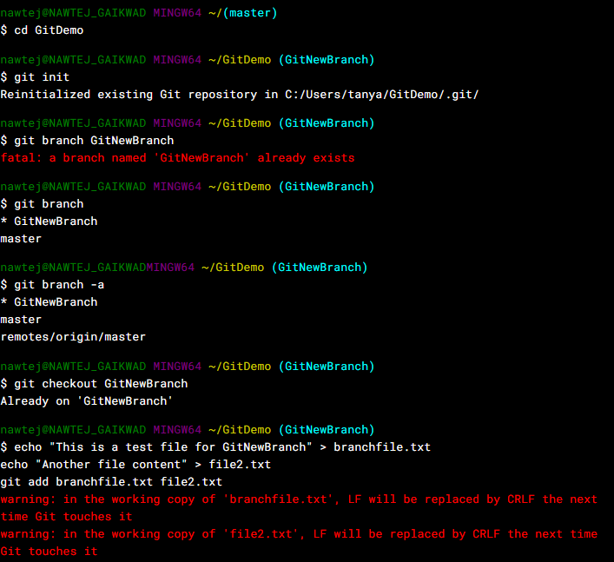

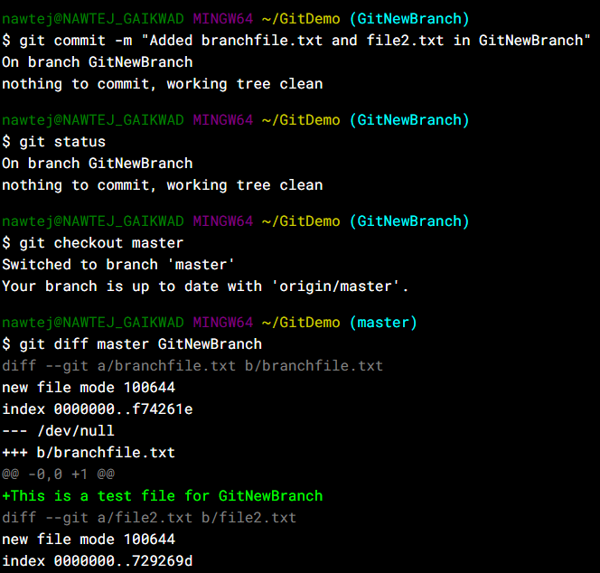

**Merging**



